- Structure of market IDs

Current Problem:
Events, markets and outcome identifiers have different structures between Kalshi and POLY. We need to normalise everything to a single model, while verifying that we collect and store all data needed to identify events and markets.

Solution POLY:
The id field (in our example: "1222896", https://gamma-api.polymarket.com/markets/1222896) is unique to the entire market and represents both the YES and NO outcomes together.
Market ID (id) is unique per market. Each market has one unique id that represents the entire binary market (both YES and NO sides). Each YES or NO is represented by the clobTokenIds (which is our current market_id).

Database design changes:
- Create new column - event_id
- Populate the POLY id into the new column event_id.
- The current market_id column remains the same - populated with the token_id which represents the outcome side.

Solution Kalshi:

Kalshi Structure Analysis
- Event-level identifier: event_ticker is shared across both outcomes
  - Example: "KXNCAAMBGAME-26FEB10MILWIUIN" (same for both), in event: https://api.elections.kalshi.com/trade-api/v2/markets/KXNCAAMBGAME-26FEB10MILWIUIN-IUIN
- Market-level identifier: ticker is unique per outcome
  - Market 1: "KXNCAAMBGAME-26FEB10MILWIUIN-IUIN" (IU Indy to win)
  - Market 2: "KXNCAAMBGAME-26FEB10MILWIUIN-MILW" (Milwaukee to win)
- Direction indicator: yes_sub_title tells you which team/outcome this market represents (a text definition to the outcome).

Database design changes for Kalshi
- Populate the new event_id column with the value from event_ticker in the API (example from https://api.elections.kalshi.com/trade-api/v2/markets/KXNCAAMBGAME-26FEB10MILWIUIN-IUIN: "event_ticker"="KXNCAAMBGAME-26FEB10MILWIUIN")
- Populate market_id with full unique market identifier, under “ticker” in the API for example: https://api.elections.kalshi.com/trade-api/v2/markets/KXNCAAMBGAME-26FEB10MILWIUIN-IUIN: the identifier is "ticker": "KXNCAAMBGAME-26FEB10MILWIUIN-IUIN".

The end result for this fix will look like:

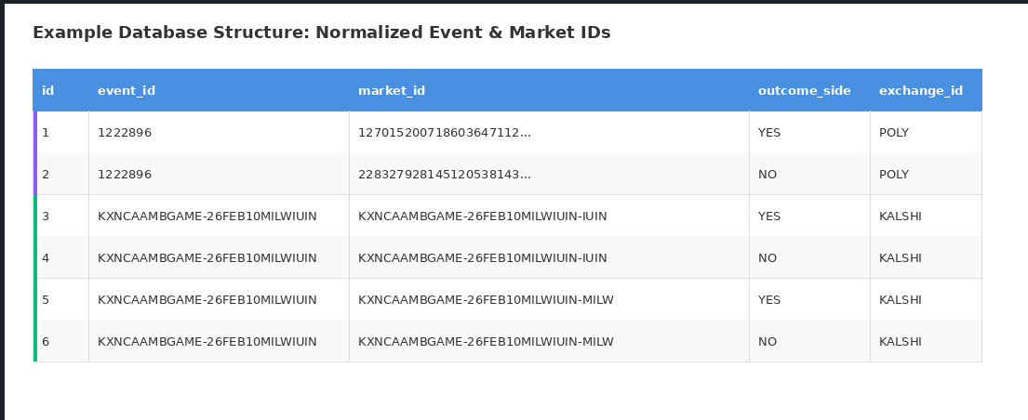

- Additional Info fields in prediction_markets metadata table

Resolution info:

Polymarket:
- description field: Contains detailed resolution rules and criteria
- Example: "This market will resolve to 'Yes' if the MLB and MLBPA sign a new collective bargaining agreement (CBA) by December 1, 2026, 11:59 PM ET..."

Kalshi:
The resolution details are split across multiple fields:
- rules_primary: Main resolution condition
  - Example: "If Milwaukee wins the Milwaukee at IU Indy men's college basketball game originally scheduled for Feb 10, 2026, then the market resolves to Yes."
- rules_secondary: Additional rules, edge cases, postponements
  - Example: "If this game is postponed or delayed, the market will remain open and close after the rescheduled game has finished (within two weeks)..."
- title: The question itself
  - Example: "Milwaukee at IU Indy Winner?"

Solution

- Change the name of description column to rules_primary and populate the POLY long string there form description in API
- Kalshi - map rules_primary in API to rules_primary in our DB
- For Kalshi add rules_secondary in our metadata table as a new column and do the proper mapping.

- Fees and interest

Exchanges can apply fees (sometimes gas fees or others), they can also pay interest on Money deposit (awaits expiration) as Kalshi does. The interest rate is attached to each market prior to taking a position.

